Warehouse Automation Project Orders Declined by 3% in 2024
- Analysts estimate a 3% decline in warehouse automation order intake in 2024
- Political, economic and market-specific factors slow pace of orders
- However, a long term annual growth rate of 8% is projected
London, 4th February 2025 – Warehouse automation orders declined by 3% in 2024, according to market intelligence specialist Interact Analysis. Its latest analysis found the decline was due to economic, political and market-specific challenges, including persistently high interest rates in many territories, and the residual effects of an oversupply of warehouses built during the Covid-19 pandemic. Additionally, increasing competition from Chinese vendors is expected to drive down prices and slow revenue growth over the forecast period to 2030.
Global macro-economic factor such as high interest rates, political uncertainty around elections, and the Chinese real estate crisis have significantly impacted sales cycles, slowing the pace of orders. Despite the forecasted decline, growth is expected to pick up from 2025, which is anticipated to mark a year of slow recovery for the sector. Pre-pandemic growth levels are expected to return from 2026, with long term expansion projected at a compound annual growth rate (CAGR) of 8% between 2024 and 2030.
Food & Beverage and durable manufacturing buck the decline
The durable manufacturing and food & beverage industries continued to spend on automation during the downturn. Warehouse automation revenues in the food & beverage sector were bolstered by cold-chain automation, as well as by large-scale projects from CPG manufacturers. Manufacturing spending was driven in part by generous government subsidies in territories such as the US, although these are expected to be stripped back by the Trump Administration (Trump will look to spur domestic investments through tariffs). These two sectors registered the highest growth in warehouse automation revenues between 2022 and 2024, with increases of 11% (durable manufacturing) and 10% (food & beverage).
Meanwhile, fulfillment investment is expected to return in the mid-term as online retailers fully utilize capacity created during the Covid-19 pandemic and look to expand their networks with new greenfield projects. These factors contribute to Interact Analysis’ projection of a 9% CAGR in the warehouse automation market between 2026 and 2030.
Macro-economic challenges continue to dampen global warehouse automation market growth
Although global challenges such as high interest rates deterring largescale investment and geopolitical tensions are having a negative impact on investments in fulfillment center automation, growth is anticipated to return as e-commerce demand stabilizes and e-tailers expand their networks. Between 2027 and 2030, a rise in fulfillment projects is forecast to contribute to a CAGR of 28% in warehouse automation order intake.
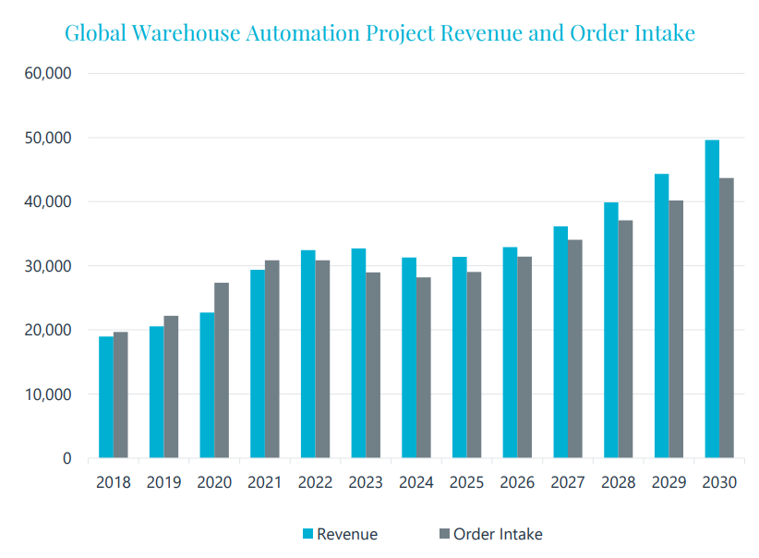
Warehouse automation order intake is expected to show strong growth from 2026
Sluggish consumer spending in China caused by the housing crisis continues to dampen warehouse automation investment and is not expected to pick up in the short term.
Commenting on the latest warehouse automation forecasts, Rowan Stott, Senior Research Analyst at Interact Analysis, says, “We anticipate that warehouse automation investments in the US will increase in 2026 as end-customers settle into the new president’s policies, resulting in an uptick in revenue in 2027.
“Europe is expected to lag behind the US in terms of an economic recovery, particularly Germany and the UK which have both experienced sluggish economic growth in recent years. However, Eastern Europe is proving to buck the trend as the region is experiencing an influx of foreign direct investment (FDI) from the likes of Western European companies re-shoring production, as well as Chinese companies looking to enter the European market.”

About the report
Our Warehouse Automation report guarantees to provide the most comprehensive and detailed analysis of the market. To produce the report, we’ve spent months conducting more than 100 in-depth research interviews and analyzed more than 120 companies, looking specifically at their past, present, and future investments in warehouse automation.
The premium version contains a mid-year update to adjust forecasts made in the standard version, six months after initial release. It also contains access to product news and financial databases to reduce efforts spent by internal marketing teams in collecting this data themselves. Also included is a Warehouse Automation Services Excel which breaks out the after-sale services and provides forecasts into the different services.

About Interact Analysis
With over 200 years of combined experience, Interact Analysis is the market intelligence authority for global supply chain automation. Our research covers the entire automation value chain – from the technology used to automate factory production, through inventory storage and distribution channels, to the transportation of the finished goods. The world’s leading companies trust us to surface robust insights and opportunities for technology-driven growth. To learn more, visit www.InteractAnalysis.com.

