Ultra-low voltage market grows by 0.1% in 2024, growth period expected in 2025
- Ultra-low voltage motors and drives market grew by 0.1% in 2024
- De-stocking continues to impact market growth
- 2025 outlook remains positive with recovery and return to growth expected
London, 18th August 2025 – The ultra-low voltage motors and drives (ULV) market faced a challenging period in 2024 with global revenue growth of 0.1%. This low growth period is an extension of the declining environment that began post-COVID in 2023. Macro-economic headwinds, ongoing inventory corrections, and weaker-than-expected industrial activity across key automation sectors also contributed to the underwhelming performance of the ULV market in 2024.
While 2024 wasn’t the rebound year that many had hoped for, 2025 is expected to be a year of growth, powered by battery-driven applications such as mobile robotics. 2025 will mark the beginning of a more sustained period of growth for the ULV market, though with varied performance across the regions.
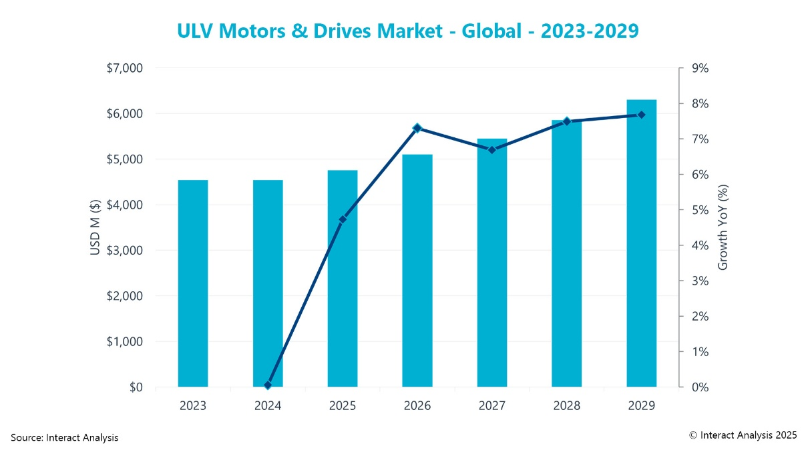
Recovery and a return to steady growth is forecast for the ULV market from 2025
Regional perspectives
The overall ULV market grew 0.1% in 2024, however, performance across the different regions was highly variable. APAC was strongest with 2.7% growth, whilst EMEA, was the worst performing region contracting -2.1%. Growth in the APAC region was supported through significant growth in niche industries in countries such as South Korea, India and Taiwan. APAC is also well positioned for continued leadership in battery powered and high efficiency solutions which will help the region to grow further in 2025.
Whilst APAC has substantial growth and a positive outlook, the Americas and EMEA regions contracted in 2024. The Americas contracted by -1.2% due to sharp slowdowns in automated sortation systems and cutting machinery. However, softening interest rates and greater clarity on trade policies are expected to support a recovery in 2025. Similarly, the EMEA region saw a -2.1% market contraction due to lingering inflation, geopolitical instability and weak manufacturing sentiment. Germany and the UK were the weakest performers and acted as a drag on the region overall. However, demand for mobile robotics and food and beverage machinery was steady. This may be a signal as to where growth will return.
For all regions, destocking remained a key factor in 2024. The excess of inventory from 2021/2022 continued which resulted in limited new orders. However, this issue is nearly resolved with demand expected to increase in 2025.
Strong signs for ULV recovery/growth in 2025
Interact Analysis forecasts a recovery in the ULV market during 2025, primarily due to battery-driven applications, such as mobile robotics. There are signs of recalibration, particularly in APAC and the Americas regions, leading to predictions of a sustained period of growth in the ULV sector, although with some fluctuations in performance between different regions and industry sectors. The anticipated recovery is likely to be supported by softening interest rates and greater clarity on trade policies, as well as the end of the period of destocking, as demand signals and purchasing behavior align more closely through the year. Growth of 4.9% is anticipated for motors in 2025 and 4.3% for drives, supported by renewed investment in industrial automation and growing adoption of digitally integrated systems.
Blake Griffin, Research Manager at Interact Analysis, commented: “2024 marked a year of stability for the ultra-low voltage motors and drives market overall. However, the slowdown, while painful, may have cleared the way for renewed investment and strategic recalibration. Stabilizing trends in core sectors suggest that the worst is behind us and the market is gradually repositioning for a more sustained rebound in 2025.”
ENDS
About the report:
In this report, we provide detailed market size and forecast data for ultra-low voltage motors and drives, and a market share analysis of any vendor in the market with a greater than 1% share.
Our market share analysis is extensive and also includes information pertaining to strengths per vendor along with any recent M&A activity.

About Interact Analysis:

With over 200 years of combined experience, Interact Analysis is the market intelligence authority for global supply chain automation. Our research covers the entire automation value chain – from the technology used to automate factory production, through inventory storage and distribution channels, to the transportation of the finished goods. The world’s leading companies trust us to surface robust insights and opportunities for technology-driven growth. To learn more, visit: www.InteractAnalysis.com

