Off-highway electronics market revenue forecast to exceed $7bn by 2030 as global demand for components grows
- Off-highway electronics market revenue estimated at $5.3bn in 2024
- Forecast growth in market revenue to exceed $7bn by 2030
- Current market is highly fragmented and regionalized
London, 28th August 2025 – In its new Off-highway Electronics report, market intelligence leader Interact Analysis estimates overall market revenue to be $5.3 billion in 2024. Thought to be the first industry-wide attempt to determine the size of, and provide forecasts for, the off-highway electronics market, Interact Analysis predicts market revenue will reach over $7 billion by 2030.
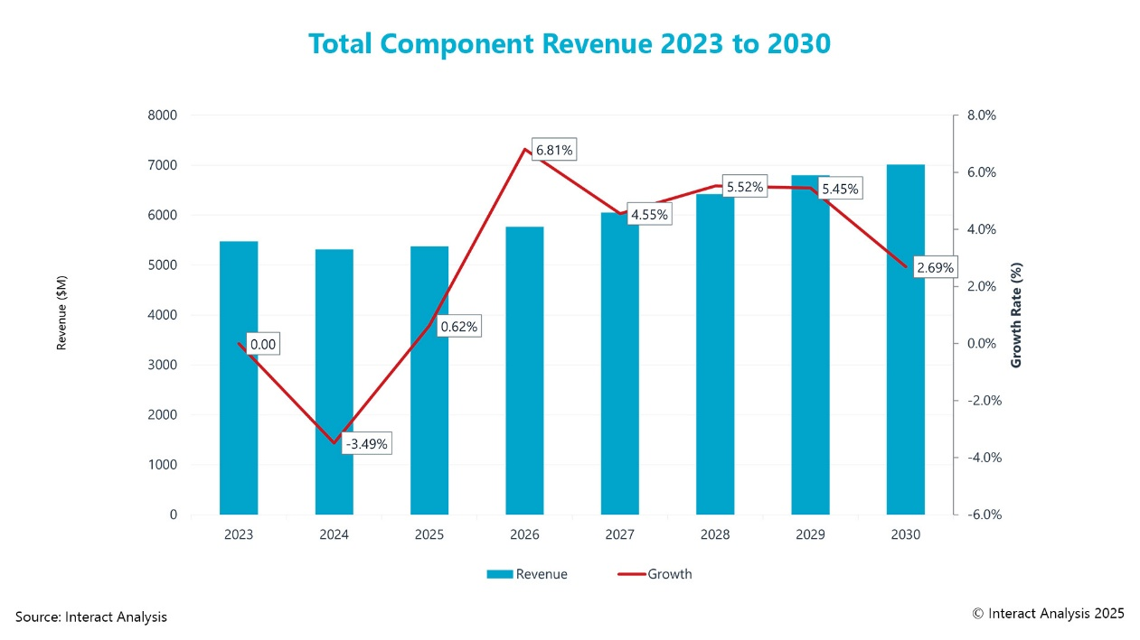
Following a dip in 2024, global off-highway electronic component revenues are expected to grow from 2025 onwards
The main revenue driver in the market is electronic control units (ECUs), with this component valued at $1.7 billion in 2024 and expected to reach $2 billion by 2030. Strong revenue growth for ECUs is anticipated due to the increasing complexity of control systems and growing demand for advanced features that require more processing power in stand-alone controllers. Therefore, as more electronic components are integrated into off-highway machinery, demand for more powerful and additional ECUs will increase.
Low-level sensors are another key market driver, representing $1.2 billion of total market revenue in 2024, as are displays and HMIs, nearing $1 billion in market revenue in the same year. This latter figure is set to increase as demand for upgraded cabins and digital displays continues to grow.
Fragmented and regionalized competition
The competitive landscape for the off-highway electronics industry is highly regionalized, as a high proportion of companies primarily serve their local markets. In addition, the market is fragmented, with numerous small and mid-sized players trying to compete against larger companies. Differences in brand recognition and reputation are two of the key factors that make it difficult for smaller companies to gain broader market traction and expand outside their core markets. Many of these smaller companies currently don’t offer a range of products, reducing their impact on the market still further.
Advanced feature adoption is OEM-led
Currently, there are no regulatory mandates relating to safety features for off-highway machinery. Therefore, adoption of advanced safety features must be driven by OEMs. While the market for off-highway machinery safety technology is currently smaller than other industries where regulatory mandates have driven widespread adoption – such as automotive – there is long-term growth potential, especially if regulations are imposed.
Chloe Mason, Market Analyst at Interact Analysis, says: “This is the first report of its kind for off-highway electronics. It demonstrates the complexity of the market and its strong potential for revenue growth – forecast to climb from $5.3 billion in 2024to over $7 billion by 2030.”
###
About this report
In the past 20 years, the automotive market has witnessed a dramatic transition from minimal use of electronics in vehicles to electronics becoming the highest value part of most vehicles.
Off-highway machinery has traditionally been mechanical and hydraulic, but recent advancements in robust and high-performance electronics – driven by the automotive market – mean these sectors can be enabled with more precise control, enhanced efficiency, and improved safety. The integration of electronics allows for real-time data collection, monitoring of performance, and predictive maintenance, which reduces downtime and operational costs.
This new report outlines the opportunities in a market poised for rapid growth.
About Interact Analysis
With over 200 years of combined experience, Interact Analysis is the market intelligence authority for global supply chain automation. Our research covers the entire automation value chain – from the technology used to automate factory production, through inventory storage and distribution channels, to the transportation of the finished goods. The world’s leading companies trust us to surface robust insights and opportunities for technology-driven growth. To learn more, visit www.InteractAnalysis.com.

