Growth for global manufacturing output in 2025, despite challenges

- Disparity between manufacturing’s perceived downturn and actual performance.
- Total global production is expected to grow 1.9% to $46.7T in 2025.
- Some smaller Asian and European territories are registering strong growth.

London, 4th December 2025 – Global manufacturing production output is currently relatively stable and growing in multiple regions, according to the latest data from market intelligence specialist Interact Analysis. Manufacturing output growth of 1.9% to $46.7 trillion is forecast for 2025. However, underlying pessimism caused by global economic uncertainty and fears surrounding trade tariffs continue and are particularly affecting the machinery market. With access to 7-8 months of production indicators for the majority of regions for 2025, the Manufacturing Industry Output Tracker shows a clear disparity has emerged between the market's perceived downturn and its actual performance.

US production output currently remains positive despite global trade wars, with predicted growth of between 2% and 3% for 2025. Other countries where the outlook remains good include Brazil, India, China, and smaller APAC territories, which continue to show signs of expansion. While the largest economies in Europe have struggled in recent years, this is partially offset by growth in smaller, emerging countries. However, the European region as a whole is expected to register a -0.1% contraction in manufacturing output in 2025.

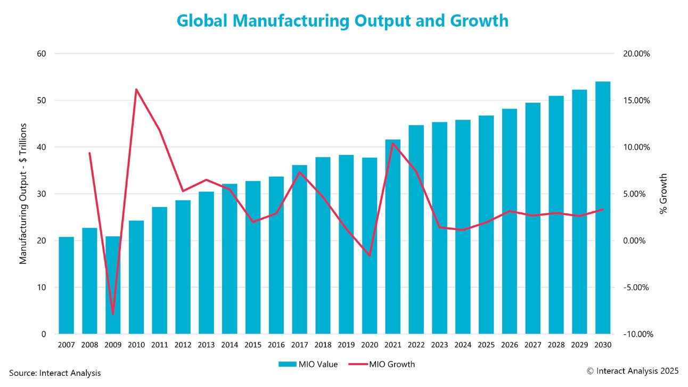
Global manufacturing output is expected to remain steady through 2030

Steady growth forecast for all regions out to 2030

All major regions are expected to see growth longer-term, but smaller territories have far more headroom to grow and significantly less baggage than their larger counterparts. Globally, manufacturing industry growth has a projected compound annual growth rate (CAGR) of 2.3% between 2025 and 2030. For 2025, the outlook in the Americas is 2.1%, compared with 2.5% in Asia, and -0.1% in Europe. Between 2025 and 2030, CAGRs are projected to hit 2.3% in the Americas, 2.3% in Europe, and 3.3% in Asia; indicating steady long-term growth overall.

Jack Loughney, Senior Data Analyst for Interact Analysis, says: “We still don’t fully appreciate what the long-term impacts of tariffs will be. With such a changeable global trade climate, it is understandable that industries, particularly more traditional ones requiring larger investments, are cautious. This is having a clear impact on machinery sales and order books, as investment is delayed while companies wait and see what the outcome of global trade wars will be.”
“However, the overall outlook for manufacturing output is for steady growth through to 2030. Smaller territories, particularly those in the APAC region and Europe, are expected to continue to benefit from stronger growth potential than their larger, more established counterparts.”
About the Report:
Manufacturing Industry Output Tracker (MIO)
In a fast-moving sector with complex correlations, it is critical to understand the state of the market now, where it was, and where it will be. This quarterly-updated tracker quantifies the total value of manufacturing production with deep granularity – for over 102 industries and sub-industries, across 45 countries, and presenting 17 years of historical data – for a complete business cycle, pre-recession to the present day.
We’ve carefully organised the country data around a common taxonomy to provide easy-to-interrogate, like-for-like comparisons. A credible five-year forecast rounds out the view.
About Interact Analysis

With over 200 years of combined experience, Interact Analysis is the market intelligence authority for global supply chain automation. Our research covers the entire automation value chain – from the technology used to automate factory production, through inventory storage and distribution channels, to the transportation of the finished goods. The world’s leading companies trust us to surface robust insights and opportunities for technology-driven growth. To learn more, visit www.InteractAnalysis.com

